Game Design Document

Fill up the Following document

1. Write the title of your project.

Tank Game

1. What is the goal of the game?

Destroy The other opponents (Tank)

1. Write a brief story of your game?

There is a tank who is lost in a forest he travelled a Journey to go to

His home back in that Journey he find many old enemies These

Enemies Attack on that tank .

The tank Fight all the other tanks (enemies)

And Go back to his home.

Happy Ending.

1. Which are the playing characters of this game?

* Playing characters are the ones which respond to the user based on the input from the user
* Cars, monkeys, dinos, wizards etc, are the playing characters in the game.

|  |  |  |
| --- | --- | --- |
| Number | Character Name | What can this character do? |
| 1 | Tank (Your Name) | He Fights with the enemy Tanks |
| 2 |  |  |
| 3 |  |  |
| 4 |  |  |
| 5 |  |  |
| 6 |  |  |
| 7 |  |  |
| 8 |  |  |

1. Which are the Non Playing Characters of this game?

* Non Playing characters are the ones which don't have an action or a behaviour when the user interacts with the game.
* Hurdles, stones, bananas, coins, etc are non playing characters in the game.

|  |  |  |
| --- | --- | --- |
| Number | Character Name | What can this character do? |
| 1 | Tank 1(White Gang (W.G)) | It will Attack On the other tank for taking his old revenge and his full team(W.G) |
| 2 | Tank 2 (W.G) | It will Attack On the other tank for taking his old revenge and his full team(W.G) |
| 3 | Tank 3 (W.G) | It will Attack On the other tank for taking his old revenge and his full team(W.G) |
| 4 | Tank 4 (W.G) | It will Attack On the other tank for taking his old revenge and his full team(W.G) |
| 5 | Tank 5 (W.G) | It will Attack On the other tank for taking his old revenge and his full team(W.G) |
| 6 | Tank 6 (W.G) | It will Attack On the other tank for taking his old revenge and his full team(W.G) |
| 7 | Tank 7 (W.G) | It will Attack On the other tank for taking his old revenge and his full team(W.G) |
| 8 | Tank 8 (W.G) | It will Attack On the other tank for taking his old revenge and his full team(W.G) |

Draw your imagination of this game. What does this game look like?

* Draw the game either on your computer or on paper,
* Add images of scenes of the game to show each of the playing and non-playing characters at least once.

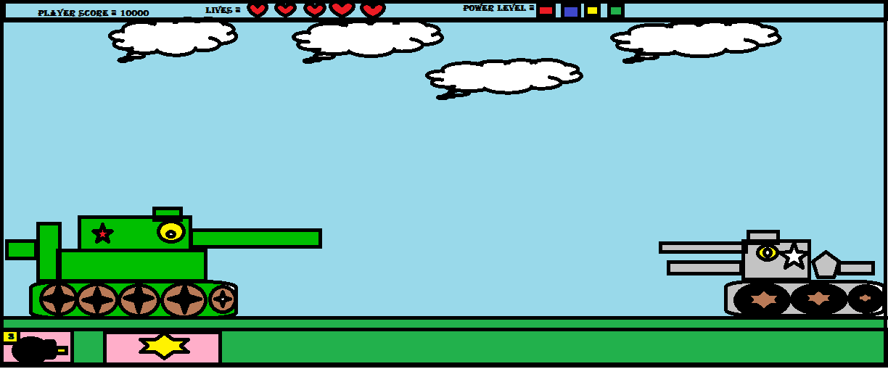

How do you plan to make your game engaging?

U can control the power , U can be as any player u want

Any color , any name , any tank

Changing of Day to Night